## WHO ARE WE

Medical Social Workers help patients and families to resolve any psychological, social, practical or emotional difficulties that arise during their time in the MS Unit.

This includes an assessment of the patient’s social, emotional and environmental circumstances to understand the impact of a new or existing illness on the patient and their family.



Medical Social Workers work to acknowledge, support and affect change for the benefit of the patient.

Medical Social Workers facilitate safe discharges from hospital and liaise with members of community services, both statutory and voluntary, to advocate for service provision for the patient. The Medical Social Worker provides a safe, confidential and supportive service.

**WHAT TO EXPECT**

At your appointment your Medical Social Worker will complete a Psychosocial Assessment of your needs. To do this they may ask you about:

* Your family, friends or support network
* How you are managing your daily activities
* Any formal supports you may have in place
* How your MS is impacting on your life from a practical and emotional perspective.
* Any difficulties you may be experiencing.

Based on your assessment your Social Worker may develop a plan that is designed to help you overcome or manage any difficulties you are having.

**ACCESSING OUR SERVICE**

If you would like to speak to a Medical Social Worker, you can ask a member of the MS Team to refer you. You or a family member can also call the Social Work Department directly.

Contact the Social Worker and together we can decide on how the service will help you.

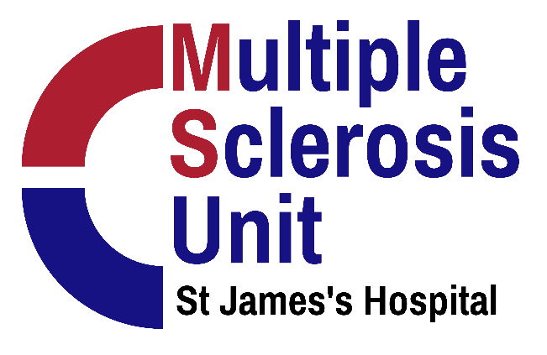

**USEFUL LINKS**

[www.citizensinformation.ie](http://www.citizensinformation.ie) - Citizens Information service gives information on a range of benefits and entitlements, the eligibility criteria and information on how to access these benefits. Some of these include Drugs Payment Scheme, Long Term Illness Scheme, Medical Card, Carers Allowance and Disability Allowance.

[www.hse.ie](http://www.hse.ie) – Find information on community supports and services near you as well as information on managing your physical and mental health

[www.ms-society.ie](http://www.ms-society.ie) – MS Ireland have a range of supports and services available to people with MS. They also have useful hints and tips on managing MS.

HOW TO FIND THE MEDICAL SOCIAL WORK DEPARTMENT

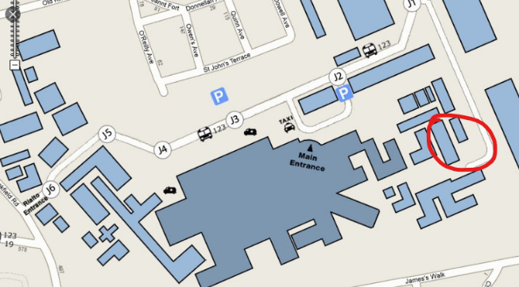

The medical social work department is located opposite the Irish Blood Transfusion Service and beside Hospital 4

Medical Social Work DEPARTMENT

**Opening Hours:**

9am – 5pm, Monday- Friday

**Telephone:**

1. 4162217

(01)4162565

**Email:** [socialwork@stjames.ie](mailto:socialwork@stjames.ie)

**Web:** <https://www.stjames.ie/services/scope/medicalsocialwork/>

